**Liquid-Liquid Equilibrium Phase Diagram**

Presented to : Professor Phillip Servio

Prepared by  
Ngan Jennifer Tram Su [260923530]

CHEE 390 – Computational Methods in Chemical Engineering  
Department of Chemical Engineering  
McGill University

2021.11.08

Table of Contents

Nomenclature 3

1 Objective 3

2 Flowchart 4

3 Results 5

4 Discussion 8

4.1 Choice in Objective Function 8

4.2 Program Considerations 9

4.21 Gaussian Elimination 9

4.2.2 Initial Guess 10

5 Conclusion 12

# Nomenclature

|  |  |
| --- | --- |
| γi | Activity of species i |
| γij | Activity of species i in the jth phase |
| xi | Mole fraction of species i |
| Tc | Upper critical solution temperature (UCST) |
| xij | Mole fraction of species i in the jth phase |

# 1 Objective

Phase splitting occurs when two liquids of limited mutual solubility meet and exhibit nonideal intermolecular interactions. At a fixed temperature and pressure, Gibb’s phase rule indicates also, a fixed set of mole fractions in each phase. The objective of this report was to determine the equilibrium immiscibility limits of a nonideal binary liquid system. Obeying the van Laar activity coefficient model, these limits were searched for in the range of 20oC to 125oC (UCST), where the limits ($x_{1}^{α}$, $x_{1}^{β}$) are both known to be 0.37 at the UCST.

# 2 Flowchart

Figure 1 follows the path that the main program[1] takes to determine the equilibrium immiscibility limits of a binary real liquid solution from 20oC to 125oC.

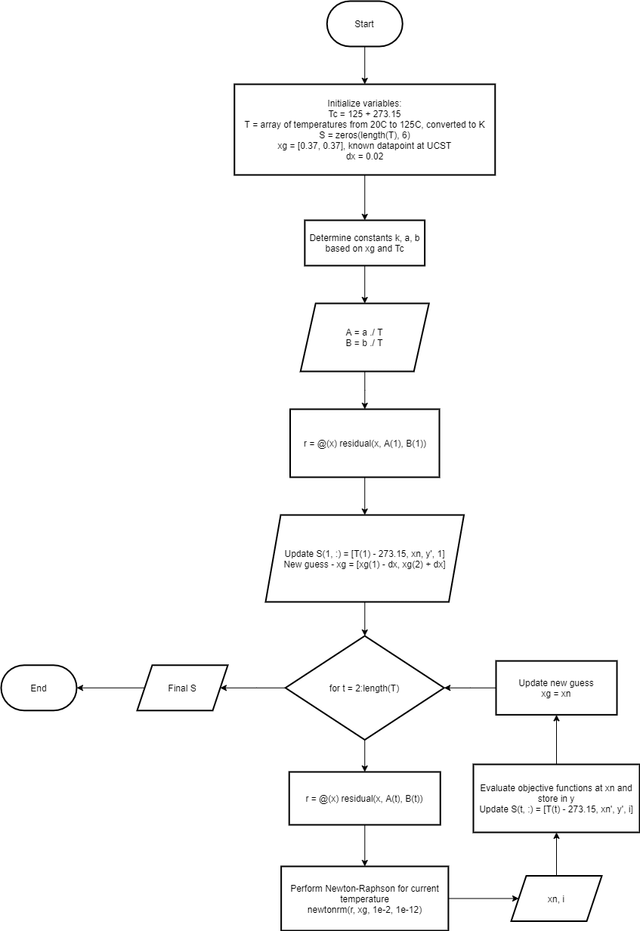

Figure 1 Main Program Flowchart

# 3 Results

At equilibrium, the objective functions (1) and (2) evaluate to zero and depend on the equilibrium immiscibility limits $x_{1}^{α}$ and $x_{1}^{β}$, the proof of which is later presented in Section 4.1 Choice in Objective Function.

|  |  |
| --- | --- |
|  | () |
|  | () |

Furthermore, to evaluate these functions, the activities of the species in each phase must be determined. While many activity models exist, the van Laar activity coefficient model is used ((3) and (4)).

|  |  |
| --- | --- |
| $$\ln\left(γ_{1}\right)=\frac{A}{{\left(1+\frac{Ax_{1}}{Bx_{2}}\right)}^{2}}$$ | (3) |
| $$\ln\left(γ_{2}\right)=\frac{B}{{\left(1+\frac{Bx_{2}}{Ax_{1}}\right)}^{2}}$$ | (4) |

Where A (5) and B (6) are constants that depend only on temperature:

|  |  |
| --- | --- |
| $$A=\frac{a}{T}$$ | (5) |
| $$B=\frac{b}{T}$$ | (6) |

And the constants a (7) and b (8) are determined as follows:

|  |  |
| --- | --- |
| $$a=\frac{T_{c}{\left(x_{1}+x_{2}κ\right)}^{3}}{2x_{1}x_{2}κ^{2}}$$ | (7) |
| $$b=aκ$$ | (8) |
| $$κ=\frac{x_{1}(1+x_{2})}{x_{2}(1+x_{1})}$$ | (9) |

The compositions in equations (7), (8), and (9) refer to the mole fractions of each species in the entire mixture, otherwise denoted as z1 and z2, and are equal to the equilibrium compositions ( $x_{1}^{α}$ and $x_{2}^{β}$) at the UCST.

These limits were determined using the Newton-Raphson method, paired with zero-order numerical continuation; given the known limits ( $x_{1}^{α}$, $x_{1}^{β}$) = (0.37, 0.37) at the UCST, the remaining limits were determined by iteratively decreasing the temperature by some small value ΔT and using the limits at the previous temperature as the initial guess (10).

|  |  |
| --- | --- |
| $$x_{guess}\left(T_{p}- ∆T\right)=x_{p}(T_{p})$$ | (10) |

Plotting temperature against these equilibrium immiscibility limits produces the phase diagram presented in Figure 1.

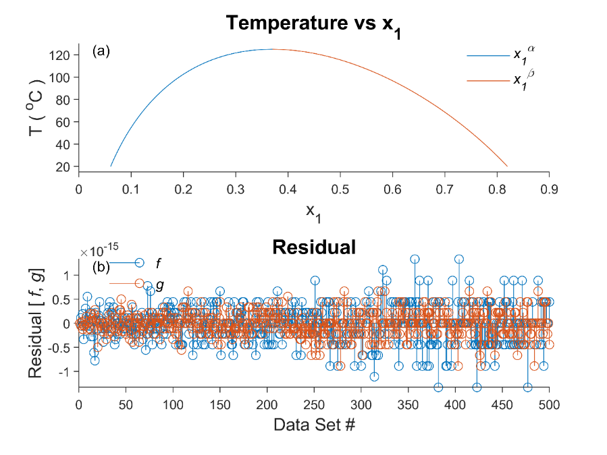

Figure 2 (a) Equilibrium Immiscibility Limits for Binary Liquid System from T = [20oC, 1250C]. (b) Residuals for Function Evaluations at $x_{1}^{α}$ and $x_{2}^{β}$.

# 4 Discussion

## 4.1 Choice in Objective Function

Without loss of generality, the following proof is presented for the objective function (1) associated with species 1.

At equilibrium, the fugacity of species 1 in both phases must be equal (11).

|  |  |
| --- | --- |
| $${\hat{f_{1}}}^{α}= {\hat{f_{1}}}^{β}$$ | (11) |

The fugacity of a species in a real mixture can be expressed in terms of the activity and the fugacity of a pure liquid species (12).

|  |  |
| --- | --- |
| $$\hat{f_{i}}= γ_{i}x_{i}f_{i}$$ | (12) |

Where $\hat{f}$ is the fugacity of the species in a real mixture, $γ$ is the activity, $x$ is the liquid mole fraction, and $f$ is the fugacity of the species in an ideal mixture. Making this substitution, the following relation is obtained:

$$γ_{1}^{α}x_{1}^{α}f_{1}= γ_{1}^{β}x_{1}^{β}f_{1}$$

In an ideal mixture, intermolecular interactions between different species are presumed to be the same as the intermolecular interactions between molecules of the pure species. As such, the ideal solution fugacity ($f_{1}$) for species 1 is the same in either phase.

$$γ_{1}^{α}x_{1}^{α}= γ_{1}^{β}x_{1}^{β}$$

Finally, through algebraic manipulation and logarithmic properties, the objective function is obtained.

$$\frac{γ_{1}^{α}}{γ_{1}^{β}} = \frac{x_{1}^{β}}{x_{1}^{α}}$$

$$\ln\left(\frac{γ_{1}^{α}}{γ_{1}^{β}}\right)=\ln\left(\frac{x_{1}^{β}}{x_{1}^{α}}\right)$$

$$\ln\left(\frac{γ_{1}^{α}}{γ_{1}^{β}}\right)-\ln\left(\frac{x_{1}^{β}}{x_{1}^{α}}\right)=0$$

$$\ln\left(\frac{γ_{1}^{α}}{γ_{1}^{β}}\right)+\ln\left(\frac{x_{1}^{α}}{x_{1}^{β}}\right)=0$$

Similarly, for species 2, the second objective function is obtained (where the mole fraction of species 2 is expressed in terms of species 1 as mole fractions must add to unity).

$$\ln\left(\frac{γ_{2}^{α}}{γ_{2}^{β}}\right)+\ln\left(\frac{{1- x}_{1}^{α}}{{1- x}_{1}^{β}}\right)=0$$

## 4.2 Program Considerations

### 4.21 Gaussian Elimination

Newton-Raphson’s method for non-linear systems of equations requires the following computation:

|  |  |
| --- | --- |
| $$x_{n}=x_{g}-J^{-1}F$$ | (13) |

Where $J^{-1}$ is the inverse of the Jacobian matrix, and F is a vector containing the objective function evaluations at $x_{g}$. With some manipulation, the following relation is obtained:

|  |  |
| --- | --- |
| $$∆x=J^{-1}F$$ |  |
| $$J∆x=F$$ | (14) |

Noticeably, the vector of interest, $∆x$, can be solved through Gaussian elimination with scaled row pivoting, followed by back substitution. Although the same result can be determined through matrix inversion, back substitution is preferred for the following reasons.

Referring to equation (14), the determination of the solution $∆x$ and the inverse matrix require Gaussian elimination with scaled row pivoting. Subsequently, the methods to obtain either value diverge, where $∆x$ is obtained through back substitution and the inverse through Jordan elimination (RREF). Comparatively, the process of Jordan elimination is computationally more expensive as it requires additional mathematical operations. Consequently, this also leads to a greater accumulation of floating-point errors. Therefore, rather than forming the inverse, it is preferable to perform back substitution following Gaussian elimination to directly obtain the solution $∆x$ to save both time and computational error.

## 4.2.2 Initial Guess

Newton-Raphson’s method is one of many root solving techniques. This method exhibits quadratic convergence and requires an initial guess from which the program can determine the roots. Ideally, the initial guess should be as close to a real root as possible. Such cases enable the quadratic nature of the algorithm to converge in fewer iterations. However, poor choices in initial guesses may result in unexpected behaviour. As Newton-Raphson’s method relies on the Jacobian (matrix of first derivatives), initial guesses near critical points may result in guesses that diverge from a root, provide inaccurate estimations or cycle in an endless loop.

For example, this report uses an initial guess of ( $x_{1}^{α}$, $x_{1}^{β}$) = (0.37, 0.37), a known datapoint which successively provided Figure 1.

* Provide examples

# 5 Conclusion

Systems at equilibrium have no tendency to change. At a fixed temperature and pressure, the compositions of each species in each phase are also fixed (by Gibb’s phase rule) and can be determined. For a binary liquid system obeying the van Laar activity coefficient model, Newton-Raphson’s method paired with zero-order continuation was employed to solve the resulting set of nonlinear objective functions. These functions are a consequence of the conditions that must be satisfied at equilibrium; namely, the equality of the fugacity of each species in each phase, which minimizes the system’s Gibb’s free energy. Using a known datapoint, a phase diagram ranging from 20oC to 125oC was produced, as well as a plot of the residual values, which elucidated the high-accuracy nature of this numerical method. Some considerations were taken in the creation of the employed algorithm. Newton-Raphson’s method requires the use of Gaussian elimination. While the solution can be obtained through back substitution or matrix inversion, the former is preferred as it is computationally less expensive and less prone to floating-point error.

* Importance of initial guess

1. Excluding the variables and code to produce the figures